CHAPTER 1: INTRODUCTION
1.1 Project Overview
Credit Card Approval Prediction Using Machine Learning is a web-based application developed to automate the process of evaluating credit card applications. Traditionally, financial institutions verify each application manually, which is time-consuming and may result in inconsistent decisions. This project uses Machine Learning techniques to analyze applicant information and predict whether a credit card application is likely to be approved or rejected.
The application is developed using Python, Flask, Scikit-learn, Pandas, and NumPy. A Decision Tree Machine Learning model is trained using applicant data containing features such as age, annual income, employment years, credit score, existing loans, loan amount, marital status, education, property ownership, and default history.
The trained model is integrated with a Flask web application that provides a user-friendly interface. Users can enter applicant details through the web page, and the application instantly predicts whether the credit card application is approved or rejected.
This project demonstrates the practical application of Machine Learning in the banking and financial sector by improving the speed, consistency, and efficiency of the credit approval process.

1.2 Purpose
The primary purpose of this project is to develop an intelligent system that assists financial institutions in making faster and more accurate credit card approval decisions using Machine Learning.
The objectives of the project are:
- To automate the credit card approval process.
- To reduce manual effort and processing time.
- To improve decision accuracy using Machine Learning algorithms.
- To provide a simple web-based interface for entering applicant details.
- To generate instant approval or rejection predictions based on applicant information.
- To demonstrate the integration of Machine Learning models with a Flask web application.
- To provide a scalable solution that can be extended for loan approval, insurance eligibility, and other financial prediction systems.
CHAPTER 2: IDEATION PHASE
2.1 Problem Statement
Financial institutions receive a large number of credit card applications every day. The traditional approval process involves manually verifying applicant information such as income, employment history, credit score, existing loans, and repayment history. This process is time-consuming, prone to human error, and may lead to inconsistent decisions.
The objective of this project is to develop a Machine Learning-based Credit Card Approval Prediction System that automates the approval process. The system analyzes applicant details using a trained Decision Tree model and predicts whether the application should be approved or rejected. This helps financial institutions make faster, more accurate, and consistent decisions while improving customer experience.

2.2 Empathy Map Canvas
Think
- Wants quick approval of the credit card application.
- Expects a fair and transparent decision.
- Looks for a simple and user-friendly application process.
Feel
- Worried about whether the application will be approved.
- Concerned about long waiting times.
- Feels confident when receiving an instant prediction.
Say
- "I hope my application gets approved."
- "I need a faster approval process."
- "The application process should be simple."
Do
- Enters personal and financial information.
- Submits the credit card application.
- Reviews the approval or rejection result.
Pain Points
- Lengthy manual verification process.
- Delayed approval decisions.
- Human errors during evaluation.
- Lack of transparency in decision making.
Gains
- Instant prediction of application status.
- Faster processing time.
- Improved accuracy using Machine Learning.
- Better user experience through a web application.

2.3 Brainstorming
During the ideation phase, different approaches to improving the credit card approval process were analyzed. Manual approval methods were compared with automated Machine Learning techniques. The project team identified that a Machine Learning model could efficiently analyze applicant information and provide accurate predictions within seconds.
Several algorithms were considered, including Decision Tree and XGBoost. A Flask-based web application was selected to provide a simple interface where users can enter applicant details and receive immediate approval predictions. This approach improves efficiency, minimizes manual effort, and demonstrates the practical application of Machine Learning in the banking sector.
CHAPTER 3: REQUIREMENT ANALYSIS
3.1 Customer Journey Map
The Customer Journey Map describes the complete interaction of an applicant with the Credit Card Approval Prediction System.
Stage 1: Application
The applicant opens the web application and accesses the credit card approval form.
Stage 2: Data Entry
The applicant enters personal and financial details including age, gender, annual income, employment years, credit score, existing loans, loan amount, marital status, education, property ownership, and default history.
Stage 3: Validation
The Flask application validates all user inputs to ensure the information is complete and correctly formatted.
Stage 4: Prediction
The validated data is sent to the trained Machine Learning model (Decision Tree), which predicts whether the application is Approved or Rejected.
Stage 5: Result
The prediction result is displayed instantly on the result page, allowing the applicant to know the application status.

3.2 Solution Requirements
Functional Requirements
- User should be able to enter applicant details.
- System should validate all input fields.
- System should load the trained Machine Learning model.
- System should predict credit card approval status.
- System should display the prediction result.
- User should be able to submit multiple applications.
Non-Functional Requirements
- Fast response time.
- User-friendly interface.
- High prediction accuracy.
- Reliable and secure application.
- Easy maintenance and scalability.

3.3 Data Flow Diagram
The data flow of the system is as follows:
Applicant
↓
Enters Applicant Details
↓
Flask Web Application
↓
Input Validation
↓
Machine Learning Model (Decision Tree)
↓
Prediction (Approved / Rejected)
↓
Display Result to User

3.4 Technology Stack
Programming Language
- Python
Machine Learning Libraries
- Scikit-learn
- XGBoost
- Pandas
- NumPy
Web Framework
- Flask
Frontend
- HTML
- CSS
Development Environment
- Jupyter Notebook
- Visual Studio Code
Version Control
- Git
- GitHub
Operating System
- Windows
CHAPTER 4: PROJECT DESIGN
4.1 Problem–Solution Fit
Problem
Banks and financial institutions receive numerous credit card applications every day. The traditional approval process requires manual verification of applicant information, which is time-consuming, labor-intensive, and may lead to inconsistent decisions. Customers often experience delays while waiting for their application status.
Proposed Solution
The proposed solution is a Machine Learning-based Credit Card Approval Prediction System that automates the approval process. The application analyzes applicant information such as age, annual income, employment history, credit score, existing loans, loan amount, marital status, education, property ownership, and default history to predict whether a credit card application should be approved or rejected.
The solution provides:
- Faster approval decisions
- Improved prediction accuracy
- Reduced manual effort
- Better customer experience

4.2 Proposed Solution
The system is developed using Python and Flask with a Decision Tree Machine Learning model trained on historical applicant data.
Workflow
- User opens the web application.
- Applicant enters all required details.
- Flask validates the input data.
- The trained Machine Learning model processes the information.
- The model predicts whether the application is Approved or Rejected.
- The prediction result is displayed instantly to the user.
This approach significantly reduces processing time while improving consistency and efficiency.

4.3 Solution Architecture
The Credit Card Approval Prediction System follows a simple client-server architecture.
Components
User
- Enters applicant information through the web application.
Frontend
- HTML and CSS pages provide an easy-to-use interface.
Backend
- Flask receives user input and processes requests.
Machine Learning Model
- The trained Decision Tree model analyzes applicant data and predicts the approval status.
Output
- The prediction (Approved or Rejected) is displayed on the result page.
Architecture Flow
User
↓
HTML Form (index.html)
↓
Flask Application (app.py)
↓
Input Validation
↓
Decision Tree Machine Learning Model
↓
Prediction Result
↓
Result Page (Approved / Rejected)
CHAPTER 5: PROJECT PLANNING & SCHEDULING
5.1 Project Planning
The project was developed following a structured approach to ensure timely completion of all phases. Each phase was planned carefully, starting from understanding the problem statement to deploying the final web application.
Project Schedule
Phase | Activities | Duration
Ideation Phase | Problem identification, brainstorming, empathy map | 2 Days
Requirement Analysis | Solution requirements, customer journey map, DFD, technology stack | 2 Days
Project Design | Proposed solution, solution architecture, project design | 2 Days
Development Phase | Dataset preparation, model training, Flask application development | 4 Days
Testing Phase | Performance testing, user acceptance testing, bug fixing | 2 Days
Documentation | Project report preparation, GitHub repository, screenshots | 3 Days
Final Submission | Review, corrections, and final submission | 1 Day
Milestones
- Problem Statement Finalized
- Dataset Collected and Prepared
- Machine Learning Model Trained Successfully
- Flask Web Application Developed
- Prediction System Tested Successfully
- Documentation Completed
- GitHub Repository Created
- Final Project Submitted
CHAPTER 6: FUNCTIONAL AND PERFORMANCE TESTING
6.1 Performance Testing
Performance testing was conducted to verify that the Credit Card Approval Prediction System performs efficiently under normal operating conditions. The application was tested for input validation, prediction accuracy, response time, and overall stability.
Performance Test Cases
Test Case ID | Scenario | Expected Result | Status
FT-01 | Applicant Data Input Validation | Valid inputs accepted and invalid inputs rejected | Pass
FT-02 | Numeric Input Validation | Only valid numeric values accepted | Pass
FT-03 | Credit Card Approval Prediction | Correct prediction displayed | Pass
FT-04 | Model Loading Check | Model loads successfully | Pass
PT-01 | Response Time Test | Prediction generated within 3 seconds | Pass
PT-02 | Multiple Prediction Requests | Application handles multiple requests successfully | Pass
PT-03 | Web Application Stability Test | Application remains stable during continuous use | Pass

6.2 User Acceptance Testing (UAT)
User Acceptance Testing was performed to ensure that the application satisfies user requirements and functions correctly in real-world scenarios.
UAT Summary
Module | Total Test Cases | Passed | Failed
Applicant Data Entry | 5 | 5 | 0
Input Validation | 4 | 4 | 0
Credit Card Prediction | 6 | 6 | 0
Result Display | 3 | 3 | 0
Overall Testing Outcome
- All major functionalities worked as expected.
- The Machine Learning model generated accurate predictions.
- Input validation prevented invalid data from being processed.
- The Flask application responded quickly and remained stable throughout testing.
- The system met the functional requirements and was considered ready for deployment.
CHAPTER 8: ADVANTAGES & DISADVANTAGES
8.1 Advantages
- Automates the credit card approval process, reducing manual effort.
- Provides fast and accurate predictions using Machine Learning.
- Reduces processing time for applicants.
- Improves consistency in decision-making.
- User-friendly web interface developed using Flask.
- Can be easily extended to support loan or insurance approval systems.
- Scalable and easy to maintain.
8.2 Disadvantages
- Prediction accuracy depends on the quality of the training dataset.
- The model may require periodic retraining with new data.
- The current system uses a limited number of applicant features.
- It is intended as a decision-support system and should not replace human review in all cases.

CHAPTER 9: CONCLUSION
The Credit Card Approval Prediction Using Machine Learning project successfully demonstrates how Machine Learning can automate the credit card approval process. A Decision Tree model was trained to analyze applicant information and predict whether a credit card application should be approved or rejected.
The model was integrated with a Flask web application, providing a simple interface for users to enter applicant details and receive instant predictions. The system was tested successfully through functional, performance, and user acceptance testing.
SCREENSHOTS:
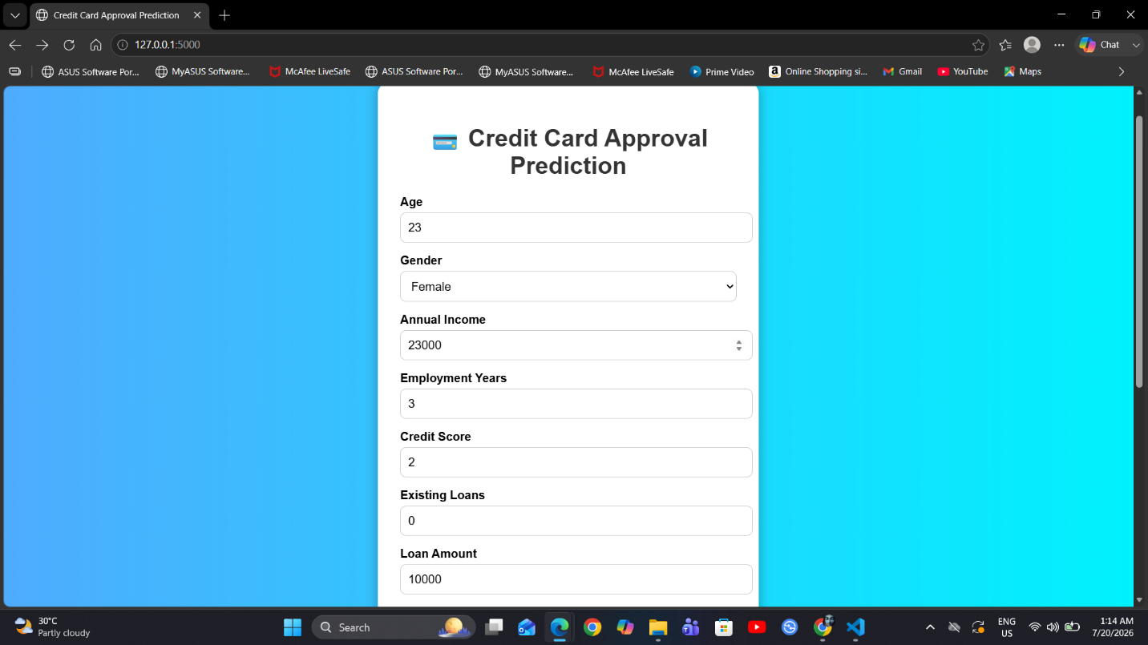

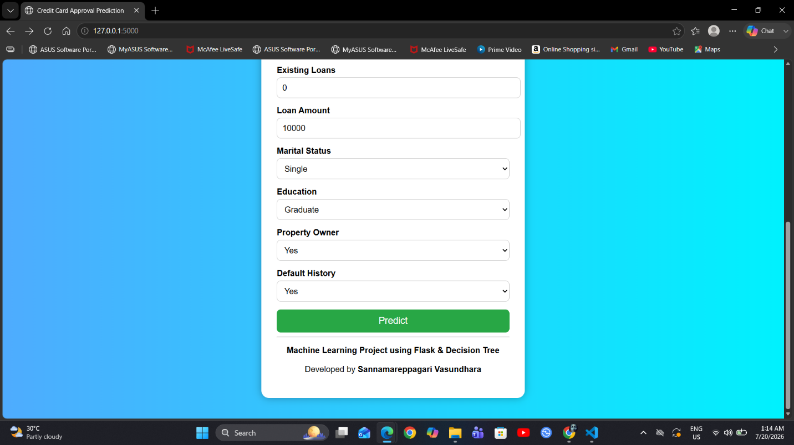
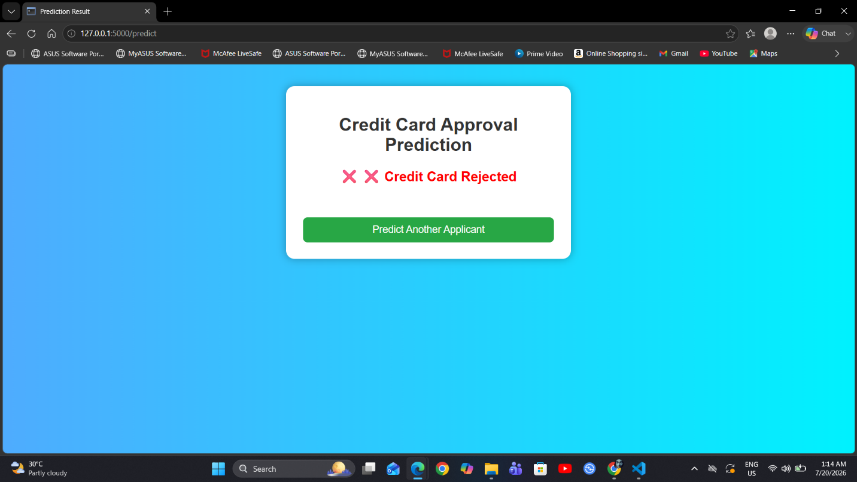
This project highlights the practical use of Machine Learning in the banking and financial sector by improving efficiency, reducing manual effort, and supporting faster, more consistent decision-making.
CHAPTER 10: FUTURE SCOPE
The project can be enhanced in several ways to improve its functionality and real-world applicability.
Future improvements include:
- Training the model with a larger and more diverse dataset.
- Evaluating additional Machine Learning algorithms such as Random Forest, Gradient Boosting, or Neural Networks.
- Deploying the application on cloud platforms such as AWS, Azure, or Google Cloud.
- Integrating the system with banking databases for real-time decision support.
- Implementing user authentication and role-based access.
- Providing explainable AI features to help users understand prediction results.
- Developing a mobile application for easier access.
CHAPTER 11: APPENDIX
Source Code
Include the important source code files used in the project:
- app.py
- index.html
- result.html
- credit_card_model.pkl
- Training Notebook (.ipynb)
Dataset
Dataset Name: Credit Card Approval Dataset
Dataset File:
- credit_card_dataset.csv
GitHub Repository
GitHub Repository Link: vasundhara361/Credit-Card-Approval-Prediction: Machine Learning project using Decision Tree and Flask for Credit Card Approval Prediction.

